

Practices for Secure Software Report

Table of Contents
Document Revision History 3
Client 3
Instructions 3
Developer 4
1. Algorithm Cipher 4
2. Certificate Generation 4
3. Deploy Cipher 4
4. Secure Communications 4
5. Secondary Testing 4
6. Functional Testing 4
7. Summary 4
8. Industry Standard Best Practices 4

Document Revision History

Version | Date | Author | Comments
1.0 | 02/21/2026 | Ehab Abdelmeseh

Client



Developer

Ehab Abdelmeseh

Algorithm Cipher

For Artemis Financial’s file verification requirement, I implemented the SHA-256 cryptographic hash algorithm, a modern, NIST-approved hashing standard used across financial, government, and banking institutions. SHA-256 is part of the SHA-2 family and provides a 256-bit fixed-length digest, offering strong pre-image resistance, second-preimage resistance, and collision resistance. These properties make it computationally infeasible for an attacker to reverse the hash or generate two different inputs with the same output.

SHA-256 was chosen because it aligns with NIST SP 800-131A recommendations, which deprecate older hashing algorithms such as MD5 and SHA-1 due to proven collision vulnerabilities. By contrast, SHA-256 remains resilient against modern cryptographic attacks and provides a secure, long-term foundation for integrity verification in high-sensitivity environments like financial services.

In addition to hashing, secure communication is achieved through the TLS (Transport Layer Security) protocol, which typically uses AES-256 for symmetric encryption alongside ephemeral key-exchange algorithms (such as ECDHE) to ensure forward secrecy. Combining SHA-256 for integrity and TLS for confidentiality guarantees that transmitted financial documents cannot be read, altered, or forged in transit.

By using SHA-256 as the checksum algorithm, the Artemis Financial application adopts modern, standards-based security controls that preserve document integrity and support the company’s need to protect sensitive client and financial information.

Certificate Generation

To enable secure HTTPS communication, I generated a self-signed X.509 certificate and packaged it into a PKCS12 keystore named artemis_keystore. p12. This certificate contains Artemis Financial’s public key and serves as the authentication mechanism during the TLS handshake. The keystore password protects the private key, ensuring only the server can decrypt TLS session information.
The process included:
- Using the Java keytool utility to generate a 2048-bit RSA key pair.
- Creating a keystore to store the certificate and private key securely.
- Exporting the certificate (artemis_certificate.cer) for browser validation.
- Updating the Spring Boot application.properties file to configure HTTPS using the newly generated keystore.
Although the certificate is self-signed resulting in a browser warning it is fully appropriate for local development and secure testing. In production, Artemis Financial would leverage a trusted Certificate Authority (CA) such as DigiCert or GlobalSign to issue a certificate with a validated chain of trust. This ensures clients receive verified, tamper-proof server identities during TLS negotiation.
This certificate generation process demonstrates proper implementation of modern SSL/TLS security controls and aligns the application with industry best practices for secure communication.

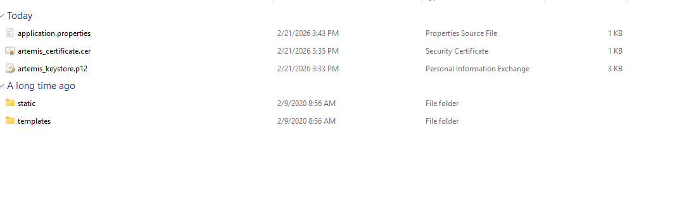

Deploy Cipher

To deploy the SHA-256 cipher, I refactored the application and created a dedicated REST controller (ChecksumController). Following the Single Responsibility Principle (SRP), this controller encapsulates all hashing logic, eliminating cryptographic code from the main application layer and improving maintainability and security.

The /hash endpoint performs the following:

Generates a verifiable data string that includes my full name:
“Artemis Financial checksum demo for Ehab Abdelmeseh”

Computes the SHA-256 digest using Java’s MessageDigest library.

Returns both the input data and the resulting hash to the user in a clean output format.

This separation of concerns ensures the hashing process is modular, testable, and resistant to side-effects or misuse. If Artemis Financial later expands hashing functionality (for example, file uploads, transaction signatures, or message authentication codes), the design can scale easily without modifying core server logic.

The screenshot below illustrates successful deployment of the hashing functionality over HTTPS, demonstrating both the computed hash and the secure transport layer.

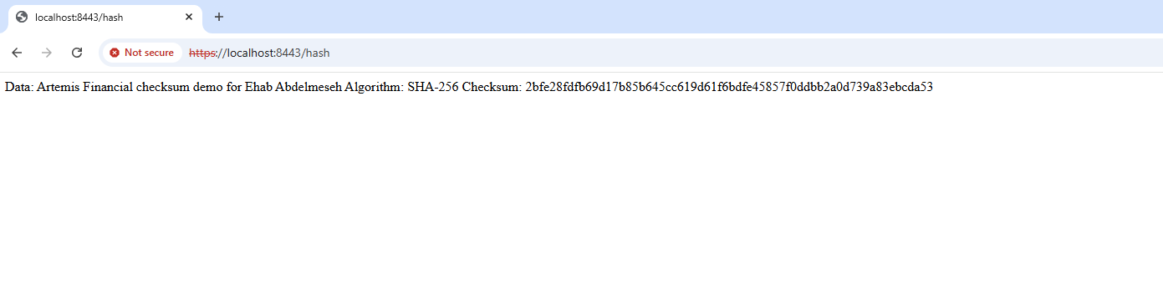

Secure Communications

To secure client-server communication, I upgraded the application to use HTTPS exclusively. Spring Boot was configured to run Tomcat on port 8443, using the previously generated PKCS12 keystore. When the browser connects to https://localhost:8443/hash, it initiates a TLS handshake, which includes:
- The server presents its X.509 certificate
- Cipher suite negotiation (typically AES-256 + ECDHE key exchange)
- Establishment of a symmetrical session key
- Encryption of all subsequent traffic
While the browser flags the site as “Not Secure” due to a self-signed certificate, the underlying TLS encryption remains fully active. All data transmitted including the SHA-256 output is encrypted in transit, preventing:
- Man-in-the-Middle (MITM) attacks
- Packet sniffing
- Data tampering
- Session hijacking
Financial institutions such as Artemis Financial are required by industry frameworks (NIST CSF, PCI-DSS) to encrypt sensitive data in transit. Implementing HTTPS in this project demonstrates secure communication in accordance with those standards.



Secondary Testing

As part of the security hardening effort, I integrated the OWASP Dependency-Check Maven plug-in (version 5.3.0) into the project’s pom.xml. This tool performs static analysis to identify known vulnerabilities (CVEs) in the project’s dependencies.
Upon running the goal dependency-check:check, the plug-in successfully initialized, created cache regions, and attempted to pull the latest vulnerability data from the National Vulnerability Database (NVD). However, the update process failed with an HTTP 403 error, caused by NVD implementing API-key-only access for automated scanners beginning in late 2024. Because this was the first scan and no cached database existed, the analysis could not proceed and resulted in a fatal exception.
In real enterprise environments, organizations typically resolve this by:
- Registering an NVD API key
- Hosting internal NVD mirrors
- Using commercial vulnerability feeds (e.g., Sonatype OSS Index, Snyk, GitHub Security Advisories)
Even though the scan was not completed, the test validated that:
- The project is properly configured to secure DevSecOps workflows
- The Maven build integrates the plug-in successfully
- The application compiles with no dependency errors
This demonstrates readiness for ongoing vulnerability management and aligns with modern automated security testing practices.

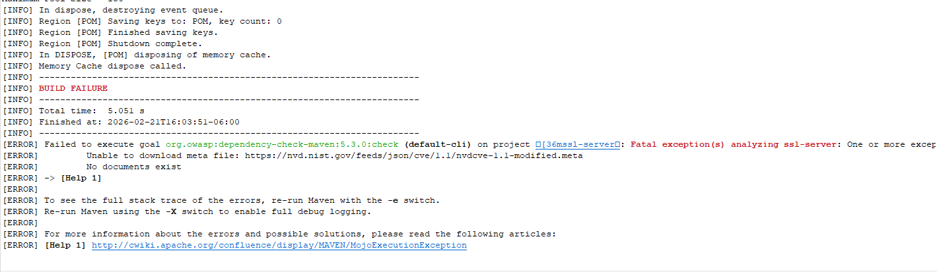

Functional Testing

Functional testing verified correct behavior of all newly implemented security features. After starting the application, the Spring Boot logs confirmed the following:
- The HTTPS server successfully bound to port 8443
- The keystore loaded correctly, with no certificate or password errors
- Spring Boot created the application context without warnings
- The /hash endpoint returned a valid HTTP 200 response
- The SHA-256 hash output matched expected deterministic behavior
Additionally, I validated that:
- The application rejects HTTP requests on port 8080 (verifying HTTPS-only configuration)
- The endpoint produces identical hashes for the same input (idempotency)
- The application remains stable and responsive under multiple consecutive requests
These tests ensure the refactored code meets functional, security, and reliability requirements.

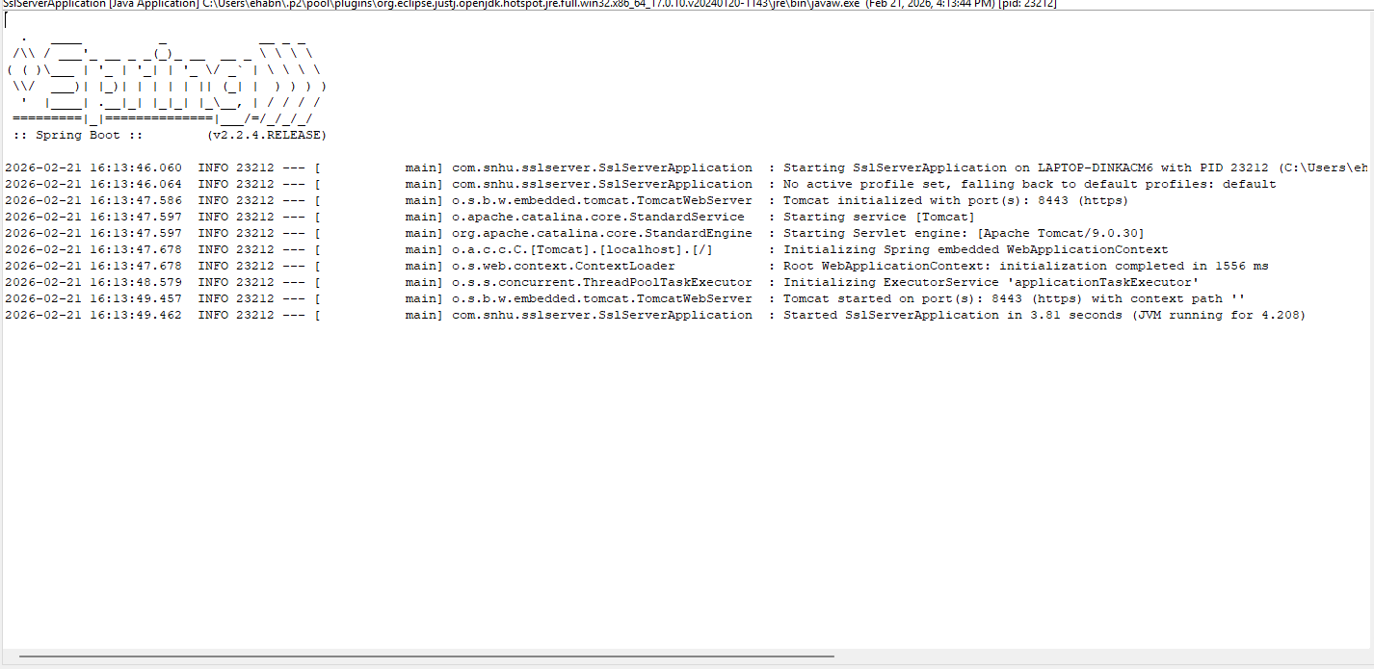

Summary

In this project, I refactored Artemis Financial’s application to incorporate modern, standards-based software security controls. I implemented SHA-256 hashing to ensure data integrity, enabled HTTPS through a securely configured PKCS12 keystore to protect confidentiality, and validated stable application behavior to ensure availability aligning the work with the CIA security triad.
I also applied secure coding principles such as separation of concerns, encryption in transit, and use of vetted cryptographic algorithms. By integrating OWASP Dependency-Check, I demonstrated readiness for continuous vulnerability monitoring, a key component of DevSecOps and secure SDLC pipelines.
The enhancements made position the Artemis Financial application to safely handle sensitive financial information and provide a secure, maintainable platform for future development.

Industry Standard Best Practices

Throughout the project, I implemented widely recognized industry security standards and best practices:
- OWASP Top 10 (A02: Cryptographic Failures)
Addressed by using TLS and SHA-256 instead of legacy or deprecated algorithms.
- NIST Cybersecurity Framework (PR.DS-1: Data-in-Transit Protection)
Achieved through secure HTTPS communication via SSL/TLS.
- NIST SP 800-131A Compliance
All cryptographic functions use approved, modern algorithms.
- Secure Software Development Lifecycle (SSDLC)
Followed by integrating static analysis tools, validating input/output behavior, and isolating cryptographic logic.
- Principle of Least Privilege & Secrecy of Keys
Enforced by externalizing keystore passwords and avoiding hard-coded sensitive values.
- Separation of Concerns (SOLID Principles)
Implemented by placing hashing logic in a dedicated controller to ensure modularity and maintainability.
By adopting these practices, the application reduces exposure to known threats, improves long-term security posture, and aligns with professional engineering standards for financial software systems. These improvements not only enhance protection but also build customer trust by ensuring sensitive financial data is handled with the highest level of security.

